**TrackWise Solutions**

**DATA PROCESSING**

### 1. Data Sources

* State factsheets for 2021, 2022, 2023 for State, Station, Guest rewards, Ridership, OTP, Route, and Employment data - <https://www.amtrak.com/about-amtrak/amtrak-facts/state-fact-sheets.html>
* Respective route pages for stations that the route connects - <https://www.amtrak.com/acela-train>

<https://amtrakguide.com/routes/>

2. Data Cleaning and Transformation

* Based on the ERD the data was split into the respective tables.
* ID Creation for having fixed length primary key
  + StateCode: A two-letter code was assigned to each state to have a fixed-length primary key for the state table. This code is similar to the state postal abbreviation used for Addresses in the US
  + StationCode: The station code mentioned on the Amtrak state factsheets was kept to maintain consistency.
  + RouteID: A four-letter code was used for each route to create a fixed-length identifier
* To maintain the database's flexibility for future data additions, the records for each year were stored as separate rows in the relevant tables, such as Rewards, Employment, and OTP. This structure allows for straightforward integration of new data without altering the database schema.
  + Example: The Rewards table was designed to store yearly data with each year's information represented as a separate row. When new data for the next year is added, new rows can just be added to the table without any change in the design itself.

|  |  |  |
| --- | --- | --- |
| **stateCode** | **rewardsYear** | **rewardMembers** |
| AL | 2021 | 36,069 |
| AL | 2022 | 50,452 |
| AL | 2023 | 58,084 |

* The stationCity column was taken from the state factsheet (City(Code)) by removing the name of the station and keeping only the name of the city. This column was created so that we can group the city for the visualization.

### 3. Importing Data

* The data was cleaned first in an Excel and then imported into the SQL server using INSERT VALUE statements

Example: For the State table, for the following few rows the insert statement was as follows

|  |  |
| --- | --- |
| **stateCode** | **stateName** |
| AL | Alabama |
| AZ | Arizona |
| AR | Arkansas |

INSERT INTO [Amtrak.State] VALUES

('AL', 'Alabama'),

('AZ', 'Arizona'),

('AR', 'Arkansas');

**FINDINGS, INSIGHTS, AND RECOMMENDATIONS (BUSINESS TRANSACTIONS)**

**What are the top ten cities with maximum ridership?**

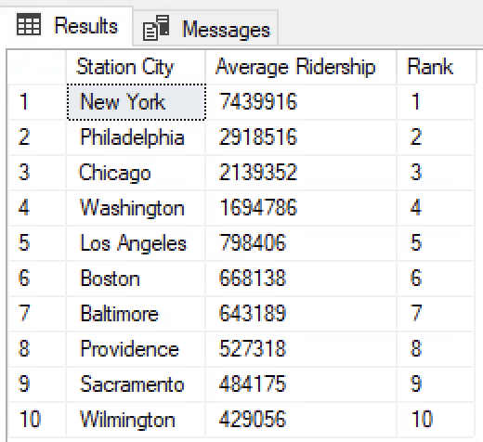

### **Insights from the SQL Query**

* **Top Performing Cities:** Our analysis identifies the top ten cities with the highest average ridership.
* **Average Ridership Values:** We provide the average ridership values for these cities, illustrating the scale of passenger traffic in each city.

### **Key Findings**

* **New York:** New York stands out with the highest average ridership, significantly leading other cities. This underscores New York's critical role in Amtrak's operations and the high demand for passenger services in this city.
* **Philadelphia and Chicago:** Following New York, Philadelphia and Chicago exhibit substantial ridership, serving as major hubs in the Amtrak network.
* **Washington and Los Angeles:** These cities also show high ridership, highlighting their importance within the network.
* **Mid-Tier Cities:** Cities like Boston, Baltimore, and Providence have moderate ridership, contributing significantly to the overall passenger volume.
* **Lower in the Top Ten:** Sacramento and Wilmington, while still in the top ten, have lower ridership compared to the leading cities.

### **Recommendations for Amtrak**

* **Enhance Services in High Ridership Cities:** We recommend focusing on improving infrastructure, services, and schedules in New York, Philadelphia, and Chicago to meet the high passenger demand effectively.
* **Capacity Management:** We advise ensuring sufficient capacity and resources are allocated to cities like Washington and Los Angeles to manage high ridership efficiently.
* **Marketing and Promotion:** To boost ridership further, we suggest promoting travel to and from mid-tier cities like Boston and Baltimore.
* **Analyze Lower Tier Cities:** It would be beneficial to investigate the factors contributing to lower ridership in cities like Sacramento and Wilmington and explore opportunities to increase passenger traffic.
* **Strategic Investments:** We recommend investing in infrastructure and service improvements in these top ten cities to maintain and potentially increase ridership, ensuring efficient and reliable operations.

**Which are the top ten states with the largest year-over-year percentage increase (and the corresponding absolute increase) in guest reward enrollments?**

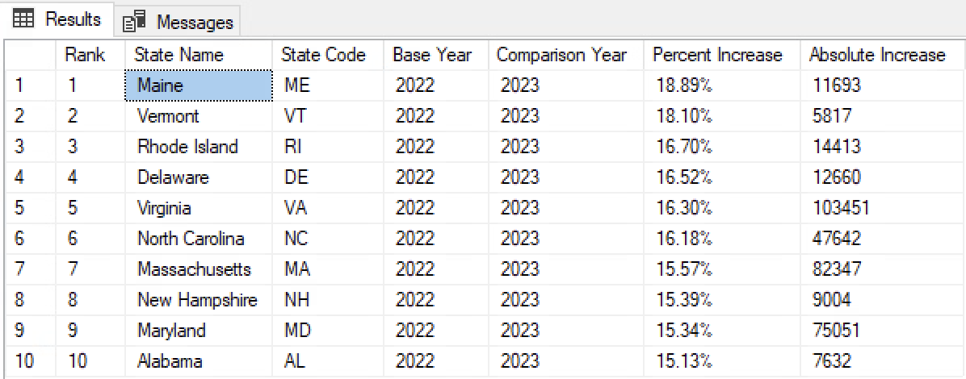

### **Insights from the SQL Query**

* **Top Cities for Guest Reward Enrollment Increases:** Our analysis identifies the top ten cities with the highest percentage increase in guest reward enrollments.
* **Percentage Increase:** We provide the value for each city's percentage increase in guest reward enrollments.
* **Absolute Increase:** We provide the value for each city’s absolute increase in guest reward enrollments.

### **Key Findings**

* **Maine and Vermont:** Maine (18.89%) stands out with the highest percentage increase in guest reward enrollments. Vermont (18.10%) shows significant growth with the second-highest percentage increase in guest reward enrollments.
* **Rhode Island and Delaware:** Rhode Island (16.70%) and Delaware (16.52%) show high percentage increases although they are smaller states.
* **Virginia:** It has the highest absolute growth (103,451 enrollments) and a substantial percentage increase (16.30%) when compared to other states.
* **North Carolina and Alabama:** North Carolina (16.18%) and Alabama (15.13%) display steady growth, having consistent rises in both percentage and absolute enrollments, making them significant performers in their respective regions.
* **Massachusetts and Maryland:** Massachusetts (15.57%) and Maryland (15.34%) retain competitive growth rates, as seen by their notable absolute increases of 82347 and 75051 enrollments, respectively. Both states showcase strong customer engagement trends in the Mid-Atlantic and New England regions.
* **Regional trends for loyalty growth:** Among the top 10 states for guest reward enrollment increases, many are located in the New England region (Maine, Vermont, Rhode Island, Massachusetts, New Hampshire).

### **Recommendations for the Company**

* **Place importance on the New England Region:** Since this region consists of several states that show strong loyalty growth, developing regional campaigns, inclusive of region-specific guest reward benefits and seasonal travel promotions (e.g. winter tour and vacation package) can help further enhance the growth experienced.
* **Capitalize on the high absolute increase in guest reward enrollments in Virginia:** Direct efforts towards retention strategies, such as enhanced member benefits in the form of travel discounts and free upgrades to encourage new enrollees to become long-term loyal customers.
* **Implement rewards campaigns:** Promote campaigns that provide special rewards like dining discounts, loyalty program upgrades, or unique member perks that encourage people to take part in the guest reward enrollment program so that states with lower increases in guest reward enrollments can experience further improvement.
* **Improve multi-channel communication:** Use social media platforms like Instagram, Facebook, and TikTok to share engaging promotional videos that increase awareness of the Amtrak Guest Rewards Program. Support these digital efforts with physical touchpoints, including onboard promotions and station kiosks to engage with passengers easily. This further complements efforts to increase guest reward enrollments across all states.

**What are the top ten states with the highest operational efficiency score, based on normalized staffing ratio and on-time performance?**

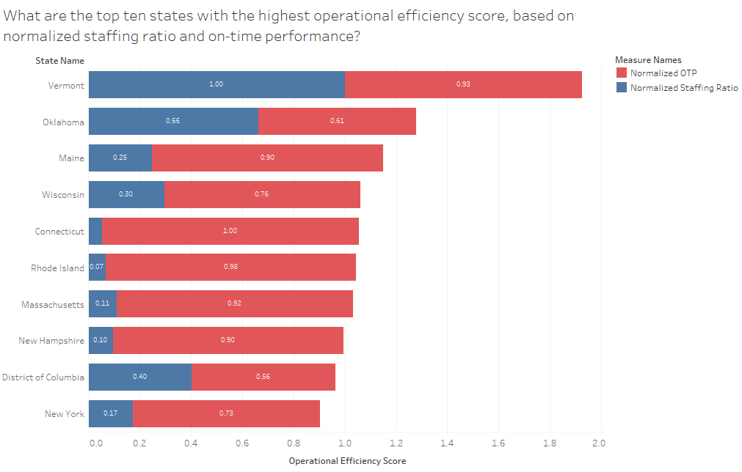

### **Insights from the SQL Query**

* **Top Performing States:** Our analysis identifies the top ten states with the highest operational efficiency scores.
* **Normalized Metrics:** We provide normalized staffing ratios and OTP values for these states, showing how each state compares relative to the best and worst performers in each category.
* **Operational Efficiency Score:** By summing the normalized staffing ratio and normalized OTP, we create an overall operational efficiency score for each state.

### **Key Findings**

* **Vermont:** Vermont has the highest operational efficiency score, indicating it has the best balance of staffing ratio and OTP among the states analyzed.
* **Oklahoma and Maine:** These states follow Vermont, showing good operational efficiency but with lower normalized staffing ratios compared to Vermont.
* **Connecticut, Rhode Island, and Massachusetts:** These states have high OTP but lower staffing ratios, contributing to their overall efficiency scores.
* **District of Columbia and New York:** These states have the lowest scores in the top ten, indicating room for improvement in both staffing ratios and OTP.

### 

### **Recommendations for the Company**

* **Best Practices from Vermont:** We recommend investigating the operational strategies employed by Vermont, as they lead to operational efficiency. Implementing similar practices in other states could help improve their performance.
* **Focus on Staffing Efficiency:** States like Connecticut and Rhode Island, which have high OTP but low staffing ratios, should focus on optimizing their staffing levels to enhance overall efficiency.
* **Improving OTP in Lower Scoring States:** States like the District of Columbia and New York need to improve their OTP to boost their operational efficiency. Investigating the causes of delays and implementing targeted interventions could help achieve this.
* **Balanced Approach:** Encourage a balanced approach to both staffing and OTP, as states with balanced metrics tend to have higher operational efficiency scores.
* **Continuous Monitoring:** Regularly monitor and adjust staffing and operational practices to ensure sustained improvements in efficiency.

**What are each route's categories (e.g. Low, Medium, High) based on their on-time performance?**

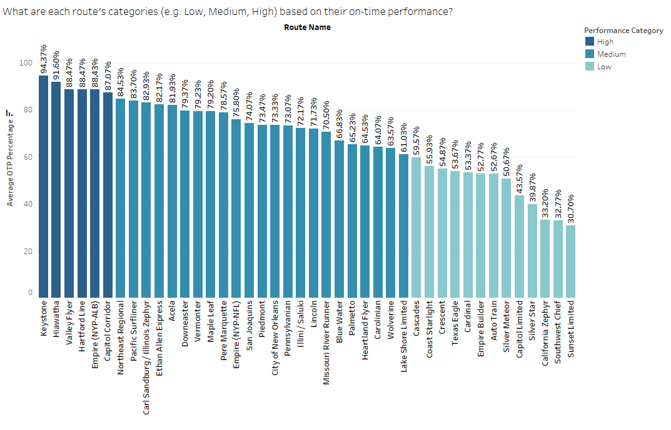

### 

### **Insights from the SQL Query**

**Route Performance Categories**

* Routes are categorized based on their average OTP percentages:
  + High: Routes with an average OTP of 85% or higher.
  + Medium: Routes with an average OTP between 60% and 85%.
  + Low: Routes with an average OTP below 60%.
* This classification helps identify which routes are performing well and which need improvement.

**Distribution of Performance Categories**

* Medium Category: The majority of routes fall into the Medium category, indicating a significant number of routes have moderate on-time performance.
* High Category: Fewer routes are categorized as High, showing that only a limited number of routes consistently achieve high reliability.
* Low Category: Some routes fall into the Low category, highlighting areas with substantial delays and operational challenges.

**Recommendations**

1. **Focus on Low-Performance Routes**

* We recommend conducting a detailed analysis of routes in the Low category to identify common causes of delays, such as infrastructure issues, scheduling conflicts, or maintenance problems.
* Implement targeted interventions like improving track conditions, optimizing schedules, and increasing maintenance efforts to enhance OTP.

1. **Best Practices from High-Performance Routes**

* Study the routes in the High category to understand what contributes to their success. Factors might include better resource allocation, effective crew management, or superior infrastructure.
* Apply these best practices to other routes, particularly those in the Medium category, to elevate their performance.

1. **Operational Improvements for Medium Routes**

* For routes in the Medium category, focus on incremental improvements. This could include minor schedule adjustments, improved coordination between connecting services, and enhanced passenger communication during delays.
* Monitor the impact of these changes regularly and adjust strategies as needed to push more routes into the High category.

1. **Customer Communication and Expectation Management**

* Enhance communication with passengers, especially on routes with Medium and Low performance. Provide real-time updates and clear information about delays and expected arrival times.
* Manage customer expectations by being transparent about efforts to improve OTP and the anticipated timeline for these improvements.

1. **Resource Allocation and Investment**

* The high-performing routes are primarily located in the Northeastern and Midwestern regions of the U.S., while the low-performing routes are concentrated in the Southwest and Southern parts.
* To improve performance, it is crucial to allocate more resources and investment to these Southwest and Southern routes, which show the greatest potential for improvement. Focus on prioritizing infrastructure upgrades and implementing technology enhancements to drive better performance on these routes.
* Consider investing in advanced scheduling software and predictive maintenance technologies to proactively address potential issues.

**FINDINGS AND INSIGHTS (STATE DASHBOARD)**

* **Maine, Vermont, Rhode Island, Massachusetts, and New Hampshire** stand out for excelling in both customer engagement and operational efficiency.
* The strong performance in **customer engagement (reward enrollments)** aligns with their **operational efficiency**, suggesting a correlation between well-managed operations and higher customer loyalty.
* For instance, Vermont's top operational efficiency score (1.93) likely supports its ability to deliver consistent, high-quality service, contributing to an 18.10% growth in reward enrollments.

**REFERENCES**

1. State factsheets for 2021, 2022, 2023 for State, Station, Guest rewards, Ridership, OTP, Route, and Employment data - <https://www.amtrak.com/about-amtrak/amtrak-facts/state-fact-sheets.html>
2. Respective route pages for stations that the route connects - <https://www.amtrak.com/acela-train>

<https://amtrakguide.com/routes/>